**Angular Installation and requirement**

1. Download node js LTS from (https://nodejs.org) official website and install.

2. Npm (Node Package Manager) – npm is a node.js package manager for JavaScript programming language. It is automatically installed with node js

3. Open command prompt (CMD)

4. Install typescript from command, a. cmd: npm install – g typescript

5. Install angular a. cmd: npm install –g @angular/cli (install latest version of command line interface) b. cmd: npm install –g @angular/8.0.2 (install a specific version of command line interface)

6. cmd: node –v (show the version of node js which you have to installed)

7. cmd: npm –v (show the version of npm which you are using)

8. cmd: ng v (show the version of Angular)

9. For create project go to a specific path a. Go to folder path, cmd: cd drive b. cmd: cd folder

10. Create project a. cmd: ng new myproject (create new angular project which name is “myproject”).

11. Go to project folder cmd: cd myproject

12. cmd: ng serve (run or compile my project. Before running, go to the project directory. For run on browser http://localhost:4200/)

13. cmd: ng serve -o (run or compile my project on command line. Before run go to project directory)

**To clear cash in npm**

npm cache clear –force

npm cache verify

**To uninstall angular**

npm uninstall -g @angular/cli

**Install Bootstrap and jquery in Angular** :

Open project and terminal, and write command

cmd > npm install bootstrap jquery

Note : After installation we can check bootstrap folder will be generated in node_modules folder

After installation open root file angular.json

add stylesheet and javascript

“style” : [

“src/style.css”,

“./node_modules/bootstrap/dist/css/bootstrap.min.css”

]

Include bootstrap js file

“scripts” : [

“./node_modules/bootstrap/dist/js/bootstrap.min.js”

]

include jquery js file

“scripts” : [

“./node_modules/jquery/dist/jquery.slim.min.js”,

“./node_modules/bootstrap/dist/js/bootstrap.min.js”

]

after that run server

cmd > ng serve

cmd > npm install bootstrap jquery --save

cmd > npm install bootstrap jquery

myproject\src\app

open file

app.component.html

and type

<button style="btn btn-danger btn-lg">Bootstrap Button</button>

<button class="btn btn-danger btn-lg">Bootstrap Button</button>

**Component :**

Component is the basic building block of angular, which means angular application is a collection of components and one component is responsible to handle one view or part of view

A component encapsulates the data, the HTML and the logic for a view. You can create as many components as required.

Component is a simple typescript class which contains, typescript class, html template/template url and @component decorator with metadata

When we develop a website, it has different different pages like home, about, contact etc. so every page we create a component and combine hole or all component we develop a website or portal

To create component “ng g c header”

**Features of angular:**

Speed and performance

Smaller application

Modular application

Cross – platform (Web, mobile and desktop)

Single page application (SPA)

Restful API

Use typescript

**Module :**

Module is a mechanism to group components, directives, pipes and services that are related, in such a way that can be combined with other modules to create an application.

**Process to create user define module**

1. cmd>ng g m newschool

2. open app.module.ts and paste the module name

imports: [

BrowserModule,

AppRoutingModule,

NewschoolModule

]

mension path of module, below is the path or import module file

import { NewschoolModule } from './newschool/newschool.module';

3. Create component under newschool module

a. cmd> ng g c school/child

b. Open “app.component.html” and write a div with some text “parent component” ( ex: <div class="bg-info"><h1>sai</h1>

<app-child></app-child> (add this attribute for to locate child path from child ts file)

</div>

)

c. Open “child.component.html” and write div with some text “child component”

d. Open “school.component.ts” file and write after imports

exports:[

ChildComponent

]

4. run cmd>ng serve

for create another module

5. cmd> ng g m sbranch

6. open sbranch.module.ts and copy class name “SbranchModule”

7. open school.module.ts and paste sbranch module name

imports:[

CommonModule,

SbranchModule

]

and also add below line

import { sbranchModule } from ‘../sbranch/sbranch.module’;

8. create component under sbranch module

a. cmd> ng g c sbranch/student

b. Open student.component.html and write some text

c. open sbranch.module.ts and write exports, after import write code

exports:[

studentComponent

]

d. Open child.component.html and write app code

<app-student></app-student>

9. cmd > ng serve

**Data Binding**

Data binding is the core concept of Angular and used to define the communication between a component and the DOM. It is a technique to link your data to your view layer. In simple words, you can say that data binding is a communication between your typescript code of your component and your template which user sees (view). It makes easy to define interactive applications without worrying about pushing and pulling data.

1. Data pass from view (component.html) to component (component.ts)

2. Data pass from component.ts to view

3. Two way binding (view to component and component to view)

Data Binding

1. One way binding

2. Two way binding

One Way Binding

1. Component to view

2. View to component

Component to view

1. Interpolation Binding

2. Property Binding

3. Attribute Binding

View to component

1. Event Binding

**Component to view:**

1. Interpolation Binding

Interpolation is a technique that allows the user to bind a value to a UI element. Interpolation binds the data one-way. This means that when value of the field bound using interpolation changes, it is updated in the page as well.

2. Property Binding

Property binding is the base method of binding in Angular, it involves binding values to DOM properties of

HTML elements. It is a one-way binding method, as values go from the component to the template layer and changes made in the component updates the properties bound in the template.

3. Attribute Binding

In Attribute Binding, you can set the value of an HTML Element Attribute directly. So, the Attribute Binding is used to bind the attribute of an element with the properties of a component dynamically.

**View to component:**

1. Event Binding

You can use Angular event bindings to respond to any DOM event. Many DOM events are triggered by user input. Binding to these events provides a way to get input from the user. To bind to a DOM event, surround the DOM event name in parentheses and assign a quoted template statement to it.

**Tow way Binding:**

Two-way data binding in Angular will help users to exchange data from the component to view and from view to the component. It will help users to establish communication bi-directionally.

**Attribute directive:**

An attribute directive changes the appearance or behavior of a DOM element. These directive look like regular HTML attributes in templates.

**Structural Directives:**

Structural Directives are directives which changes the structure of the DOM by adding or removing elements.

You can say structural directives change shape or reshape the DOM's structure.

There are three built-in structural directives, *ngIf, *ngFor and *ngSwitch

**Introduction To App- Routing:**

Routing is an important key feature for every frontend framework, it is the process of dividing the UI of an application using URLs. It allows developers to build modern single-page applications that can be loaded once by a browser and provide multiple views.

Note - For create route file write below command

cmd> ng g m app-routing --flat --module=app

--flat puts the file in src/app instead of its own folder.

--module=app tells the CLI to register it in the imports array of the AppModule.

The generated file looks like this:

src/app/app-routing.module.ts (generated)

import { NgModule } from '@angular/core';

import { CommonModule } from '@angular/common';

@NgModule({

imports: [

CommonModule

],

declarations: []

})

export class AppRoutingModule { }

Replace it with the following:

src/app/app-routing.module.ts (updated)

import { NgModule } from '@angular/core';

import { Routes, RouterModule } from '@angular/router';

const routes: Routes = [];

@NgModule({

imports: [RouterModule.forRoot(routes)],

exports: [RouterModule]

})

export class AppRoutingModule { }

Q. What is pipe ?

A. They are a simple way to transform values in an Angular Template.

Pipes are simple way to transform values in Angular Template. There are some built in pipes, but you can also build your own pipes

Types of pipe

1. Predefine Pipe

a. parameterise Pipe

b. Chaning Pipe

2. User define Pipe

a. parameterise Pipe

example

{{variable | para1:para2:para3}}

b. chaning pipe

{{variable | uppercase}}

**MongoDB**

What is mongoDB ?

MongoDB is a free and open-source cross-platform document-oriented database program.

Classified as a NoSQL database program, MongoDB uses JSON-like documents with schema

MongoDB is not RDBMS (relational database management system).

What is NoSQL ?

A NoSQL (originally referring to “nonSQL” or “non relational”) database provides a mechanism for storage and retrieval of data that is modeled in means other than the tabular relations used in relational databases.

NoSQL databases are increasingly used in big data and real-time web applications.

What is a collection ?

Collection is a group of mongoDB documents. It is the equivalent of an RDBMS table. A collection exists within a single database. Collections do not enforce a schema. Documents within a collection can have different fields. Typically, all documents in a collection are of similar or related purpose.

You can say collection as table in SQL

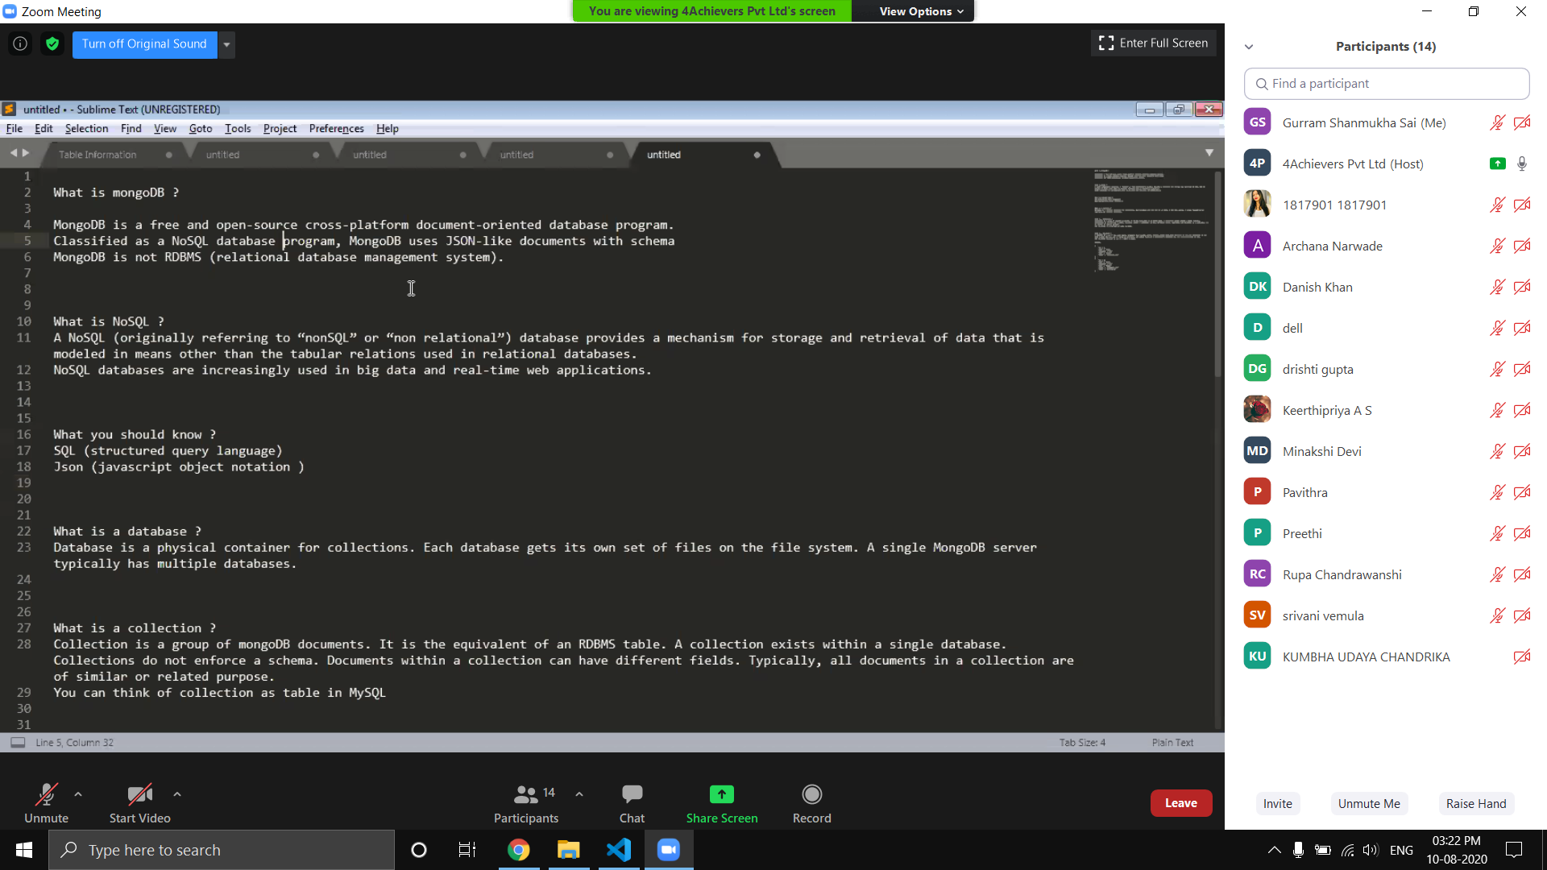

What is a Document ?

A document is a set of key-value pairs. Documents have dynamic schema. Dynamic schema means that documents in the same collection do not need to have the same set of fields or structure, and common fields in a collection’s documents may hold different types of data.

You can say document as row of a table in mysql.

Example -

{

“Id” : 1,

”Name” : “abc”,

“City” : “delhi”

}

{

“Id” : 12

”Name” : “abc”,

“City” : “Mumbai”,

“State” : “maharastra”

}